**Installing Gauge and IntelliJ IDEA Community Edition**

# 

1. First install JDK to your computer
2. Add JDK to the Windows Environment Variables  
   Variable name: JAVA_HOME  
   Variable value: C:\Program Files\Java\jdk1.8.0_101
3. Then install IntelliJ IDEA Community Edition using the following URL

<https://download.jetbrains.com/idea/ideaIC-2016.3.1.exe>

1. Install Gauge using the following URL

<https://github.com/getgauge/gauge/releases/download/v0.7.0/gauge-0.7.0-windows.x86_64.exe>

1. Download Apache Maven using the following URL  
   <http://www-us.apache.org/dist/maven/maven-3/3.3.9/binaries/apache-maven-3.3.9-bin.zip>
2. Extract it and copy that folder into the following path  
   C:\Program Files (x86)\Apache\
3. Add Maven to the Windows Environment Variables  
   Variable name: M2_HOME  
   Variable value: C:\Program Files (x86)\Apache\apache-maven-3.3.9

Variable name: MAVEN_HOME  
Variable value: C:\Program Files (x86)\Apache\apache-maven-3.3.9

1. Update PATH System Variable by adding the following

%M2_HOME%\bin

1. 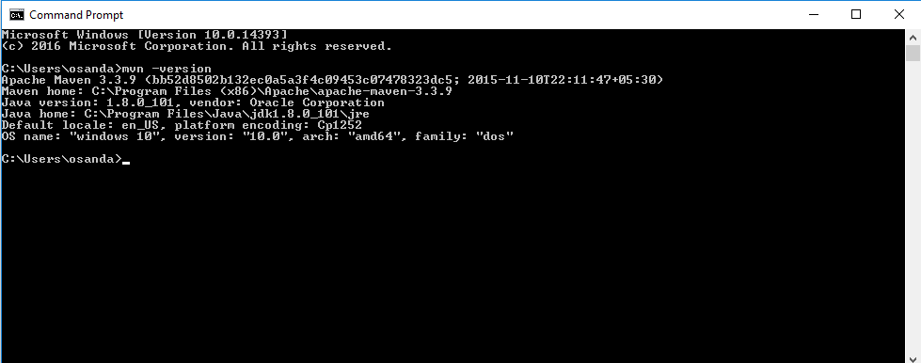Verify Maven installation using the following command on the command prompt  
   mvn –version
2. Open Command Prompt and execute following commands  
   gauge --install java  
   gauge --install html-report
3. 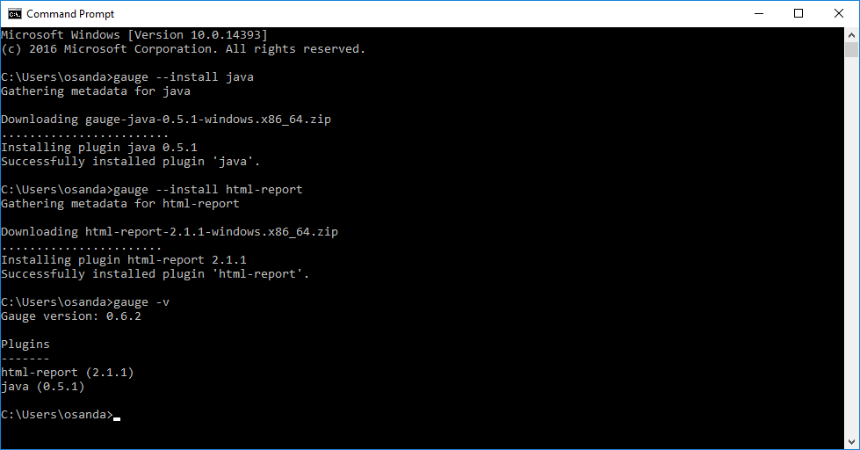You can check the installation using the following command. If the installation is success, it will output like this:  
   Gauge version: <version number>  
     
   Plugins  
   -------  
   language(<version number>)

# **Environment Variables**

1. User Variables

|  |  |
| --- | --- |
| Variable Name | Variable Value |
| JAVA_HOME | C:\Program Files\Java\jdk1.8.0_101 |
| M2 | %M2_HOME%\bin |
| M2_HOME | C:\Program Files (x86)\Apache\apache-maven-3.3.9 |
| MAVEN_REPOSITORY | C:\Users\Osanda\.m2\repository |
| Path | %M2_HOME%\bin |
| TEMP | %USERPROFILE%\AppData\Local\Temp |
| TMP | %USERPROFILE%\AppData\Local\Temp |

1. System Variables

|  |  |
| --- | --- |
| Variable Name | Variable Value |
| asl.log | Destination=file |
| ComSpec | %SystemRoot%\system32\cmd.exe |
| GAUGE_ROOT | C:\Program Files\Gauge |
| NUMBER_OF_PROCESSORS | 4 |
| OS | Windows_NT |
| Path | %SystemRoot%\system32;%SystemRoot%;%SystemRoot%\System32\Wbem;%SYSTEMROOT%\System32\WindowsPowerShell\v1.0\;C:\Program Files\Microsoft SQL Server\Client SDK\ODBC\110\Tools\Binn\;C:\Program Files (x86)\Microsoft SQL Server\120\Tools\Binn\;C:\Program Files\Microsoft SQL Server\120\Tools\Binn\;C:\Program Files\Microsoft SQL Server\120\DTS\Binn\;C:\Program Files (x86)\Microsoft SQL Server\120\Tools\Binn\ManagementStudio\;C:\Program Files (x86)\Microsoft SQL Server\120\DTS\Binn\;%USERPROFILE%\.dnx\bin;C:\Program Files\Microsoft DNX\Dnvm\;C:\Program Files (x86)\Windows Kits\8.1\Windows Performance Toolkit\;C:\Program Files\Git\cmd;C:\Program Files\MATLAB\R2013a\runtime\win64;C:\Program Files\MATLAB\R2013a\bin;C:\Program Files (x86)\Brackets\command;C:\Program Files (x86)\Skype\Phone\;C:\Program Files\TortoiseHg\;C:\curl;C:\Program Files\nodejs\;C:\Program Files (x86)\Common Files\Ulead Systems\MPEG;%JAVA_HOME%\bin;C:\Program Files\Gauge\bin; C:\Program Files (x86)\Mozilla Firefox\firefox.exe; %M2_HOME%\bin |
| PATHEXT | .COM;.EXE;.BAT;.CMD;.VBS;.VBE;.JS;.JSE;.WSF;.WSH;.MSC |
| PROCESSOR_ARCHITECTURE | AMD64 |
| SOAPUI_HOME | C:\Program Files\SmartBear\soapUI-4.5.1 |
| PROCESSOR_IDENTIFIER | Intel64 Family 6 Model 58 Stepping 9, GenuineIntel |
| PROCESSOR_LEVEL | 6 |
| PROCESSOR_REVISION | 3a09 |
| PSModulePath | %SystemRoot%\system32\WindowsPowerShell\v1.0\Modules\;C:\Program Files (x86)\Microsoft SQL Server\120\Tools\PowerShell\Modules\ |
| TEMP | %SystemRoot%\TEMP |
| TMP | %SystemRoot%\TEMP |
| USERNAME | SYSTEM |
| VS110COMNTOOLS | C:\Program Files (x86)\Microsoft Visual Studio 11.0\Common7\Tools\ |
| VS120COMNTOOLS | C:\Program Files (x86)\Microsoft Visual Studio 12.0\Common7\Tools\ |
| VS140COMNTOOLS | C:\Program Files (x86)\Microsoft Visual Studio 14.0\Common7\Tools\ |
| VSSDK140Install | C:\Program Files (x86)\Microsoft Visual Studio 14.0\VSSDK\ |
| windir | %SystemRoot% |

1. Screenshots

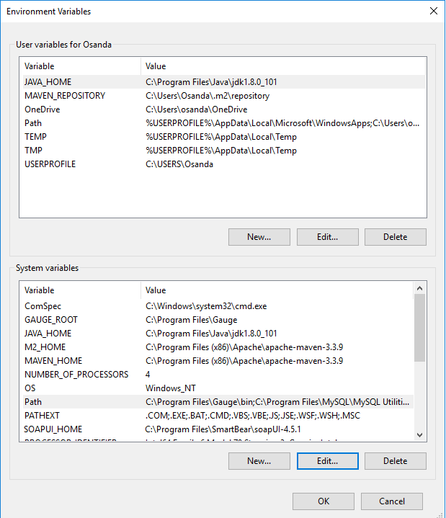

1. Path variable in “System variables” section

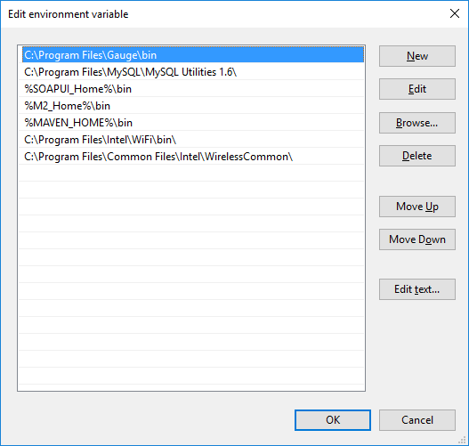

Date Created : 02/09/2017

Version : 1.1.0

Owner : Osanda Deshan <onimalarathna@mitrai.com>

Description : Installing Gauge and IntelliJ Idea Community Edition